**HOLOCAUST** 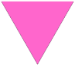

 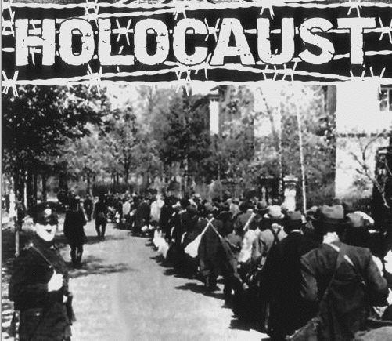

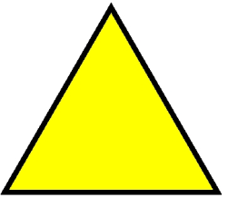 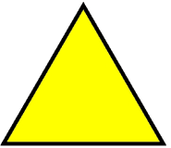 

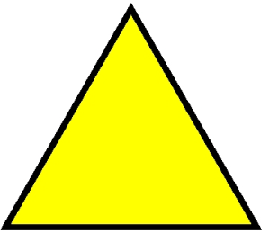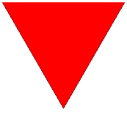

What about the **Holocaust**?

Rights, Jews, genocide, gas chamber, Nazism and the II World War?  
There are a lot of words and sentences to spend about this issue, you know?

The Holocaust (a.k.a. the **Shoah**) was the genocide of approximately six million European Jews during World War II, a programme of systematic state-sponsored murder by Nazi Germany, led by Hitler, throughout Nazi-occupied territory.

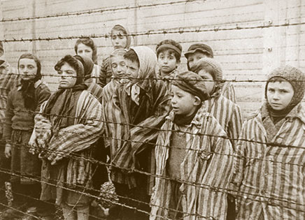

In the Nazi camps the prisoners were obliged to wear fabric triangles on their uniforms, painted in different colors, according to their category (Communists, Jehova’s witnesses, common criminals, homosexuals…) in order to be immediately identified. Jews wore a yellow triangle, overlapped by a David star.

“…When first they came for the criminals I did not speak  
Then they began to take the Jews   
When they fetched the people who were member s of trades unions

I did not speak  
Then they took the bible students  
Round they took the homosexuals   
Then they gathered up the students and the gypsies. ”

It is a song sung by Christy Moore, about what hell there was.  
Now, we just hope that one day all this about the Holocaust issue could help people have a better future. :)

Luigi ed Eleonora :)

**IIIA**